**Exercise 3a – Lab Exercises**

**Question 1 (Temperature.java)**  
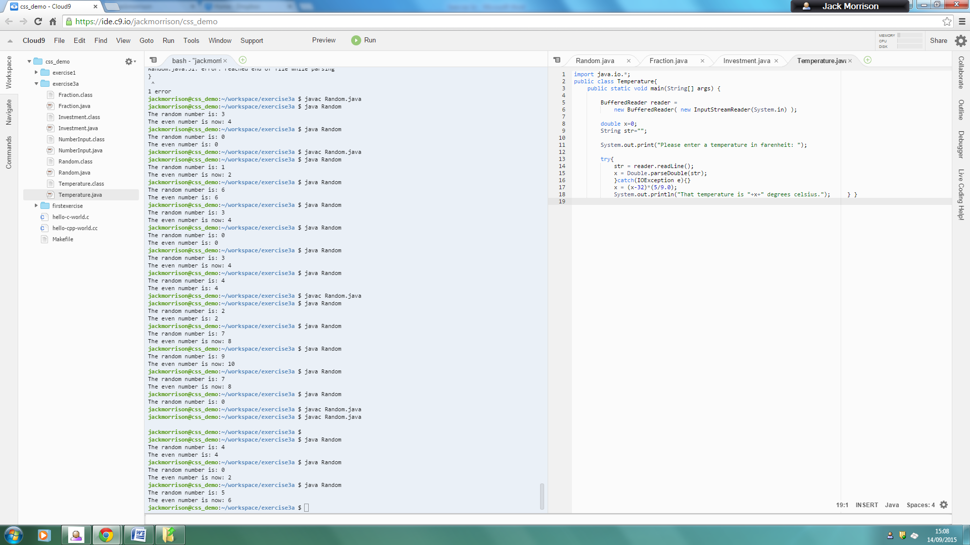

This code creates a program called Temperature.java.

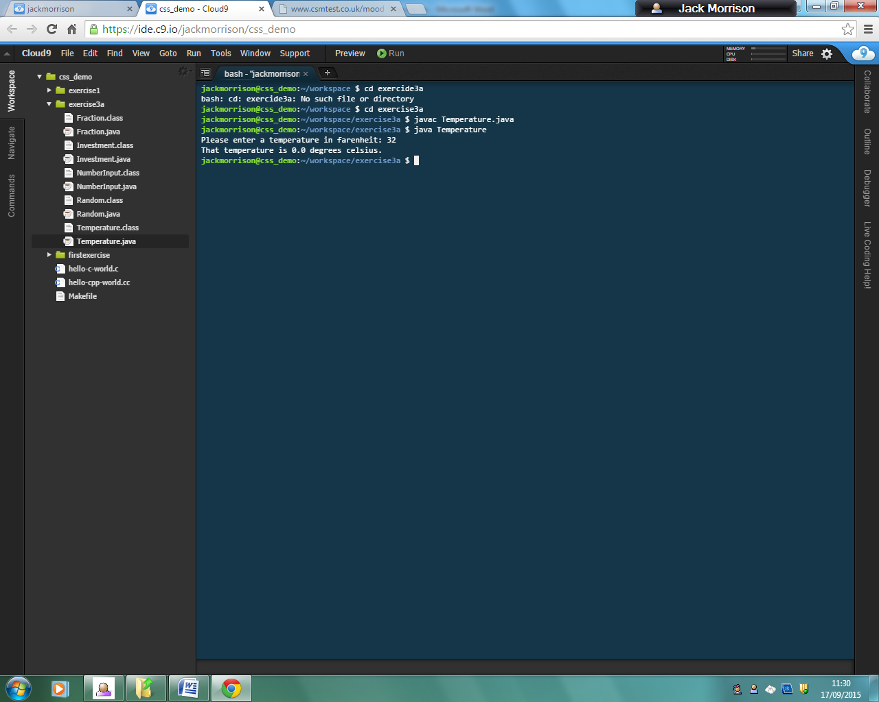

This shows that when the program is executed, it can output that 32 degrees Fahrenheit = 0 degrees Celsius.

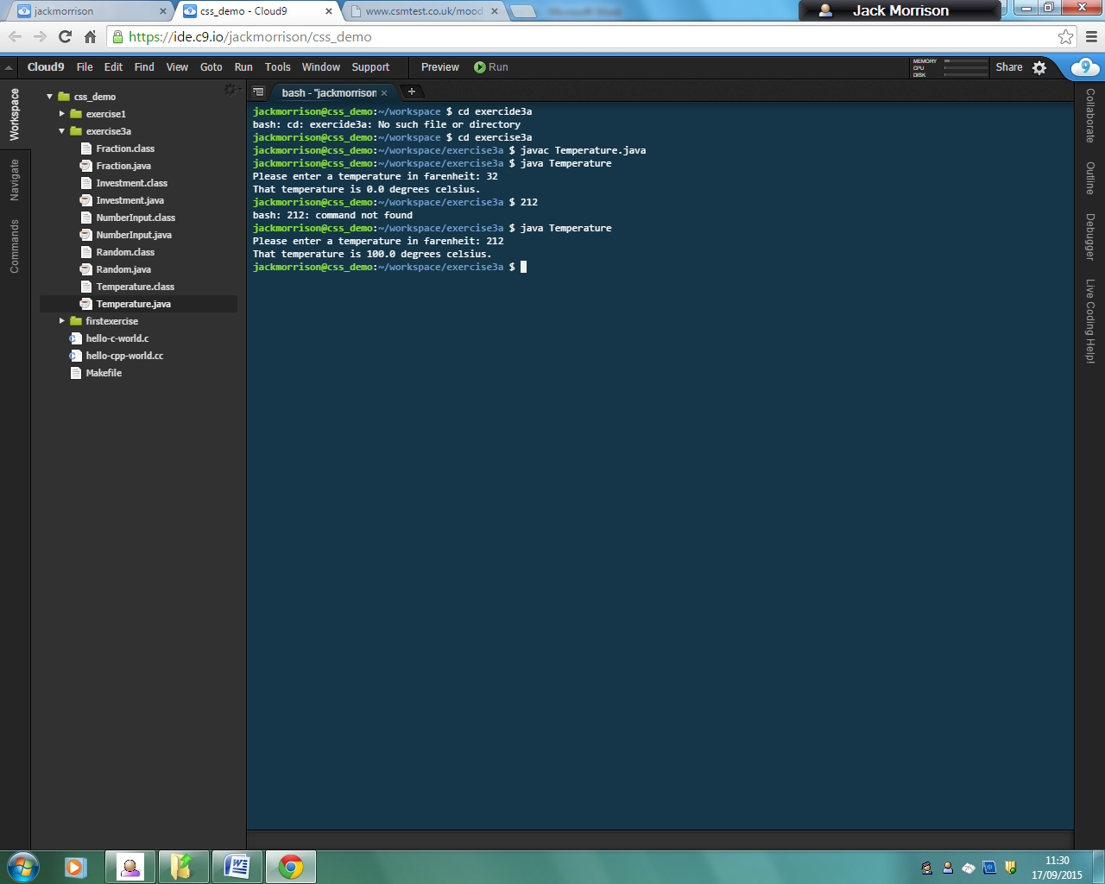

This shows that when the program is executed, it can output that 212 degrees Fahrenheit = 100 degrees Celsius.

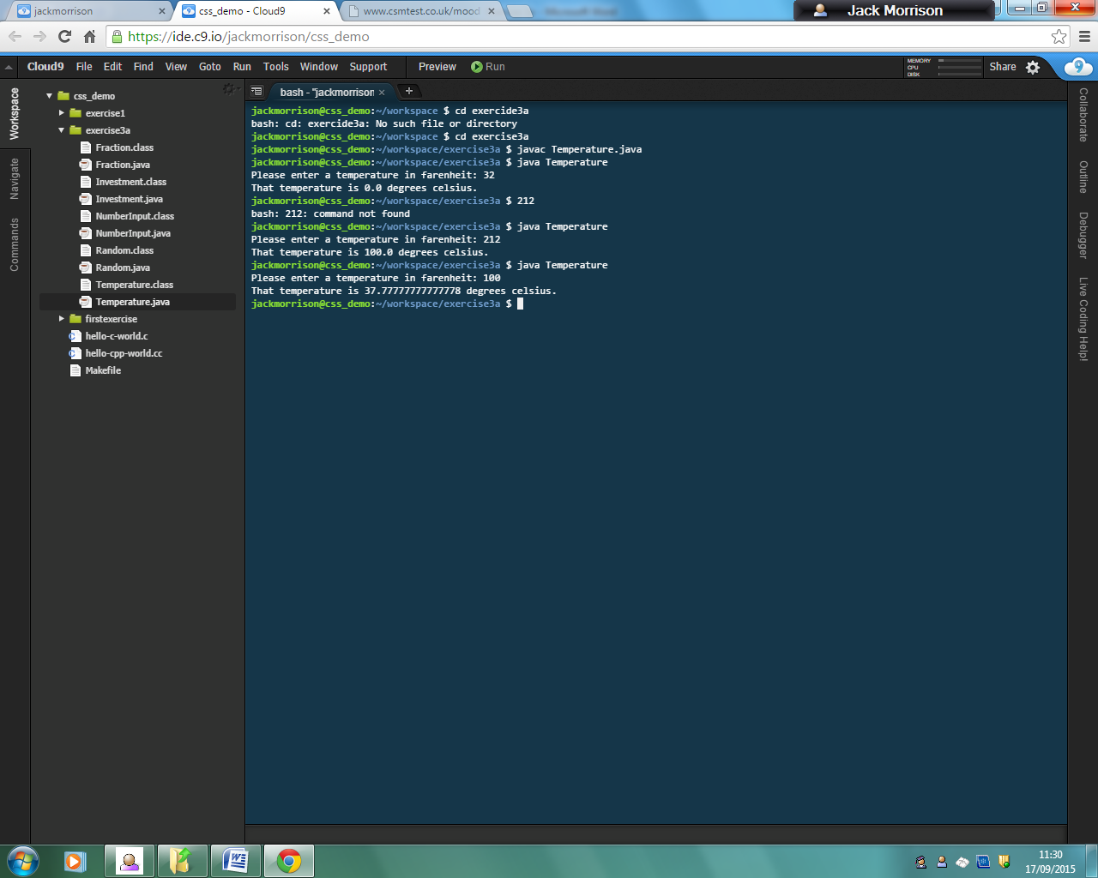

This shows that when the program is executed, it can output that 100 degrees Fahrenheit = 37.7... degrees Celsius.

**Question 2 (Investment.java)**

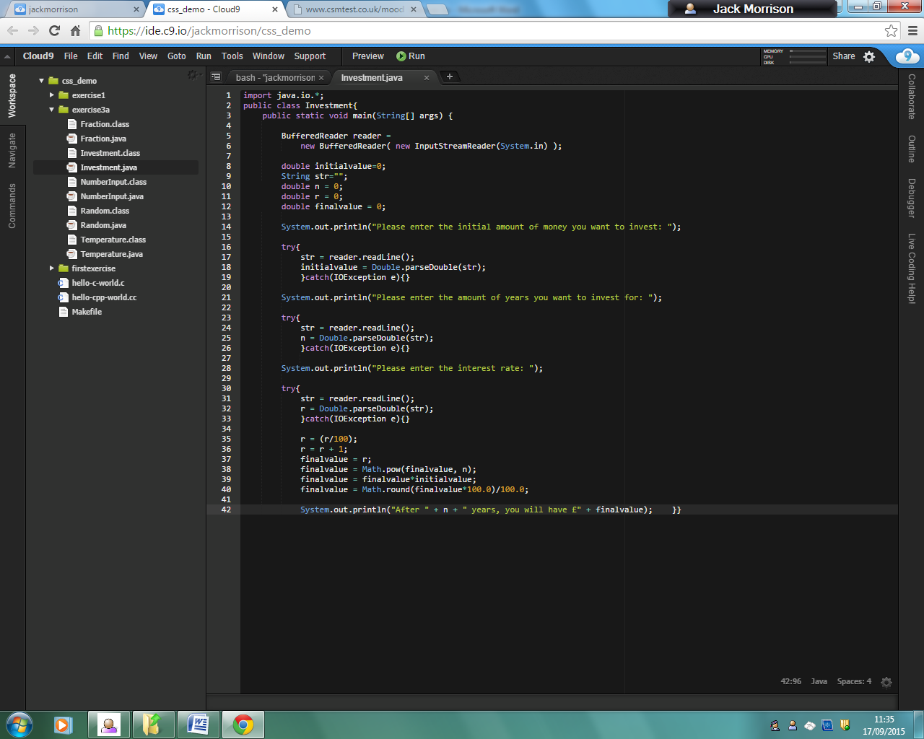

This is the code for the program Investment.java.

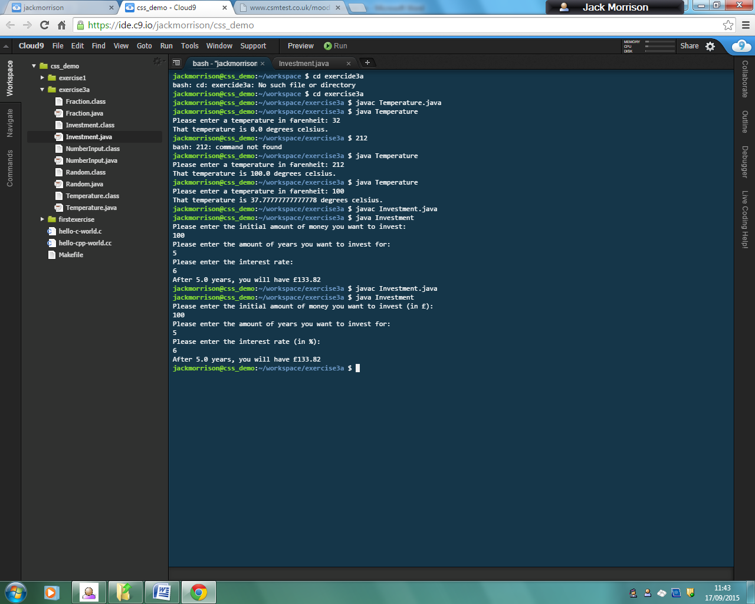

This shows that when the program is executed, and someone wants to invest £100 for 5 years at an interest rate of 6%, they will have £133.82 after the 5 years.

**Question 3 (Fraction.java)**

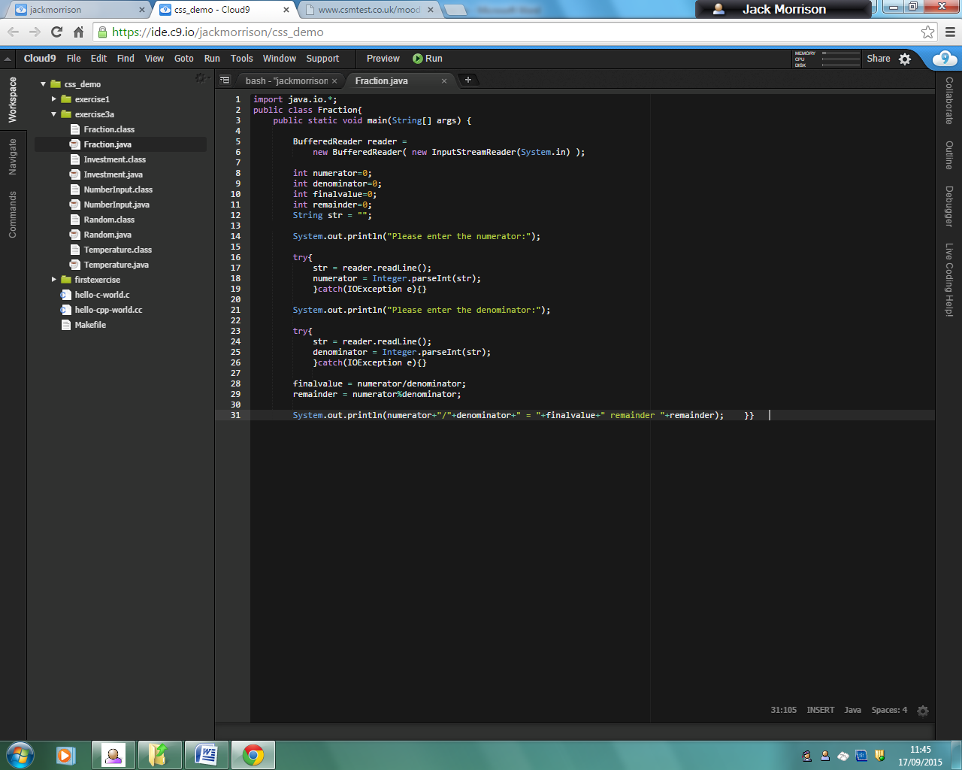

This is the code for the program Fraction.java.

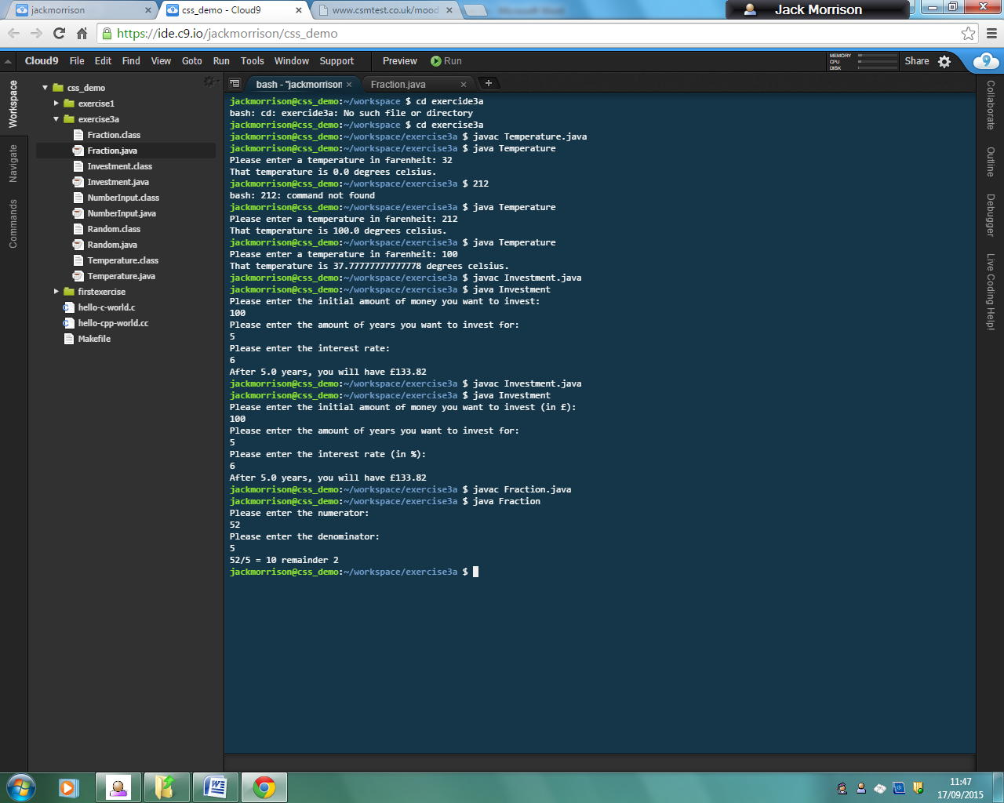

This shows that when someone enters the numerator 52 and the denominator 5, the answer is 10 with a remainder of 2.

**Question 4 (Random.java)**

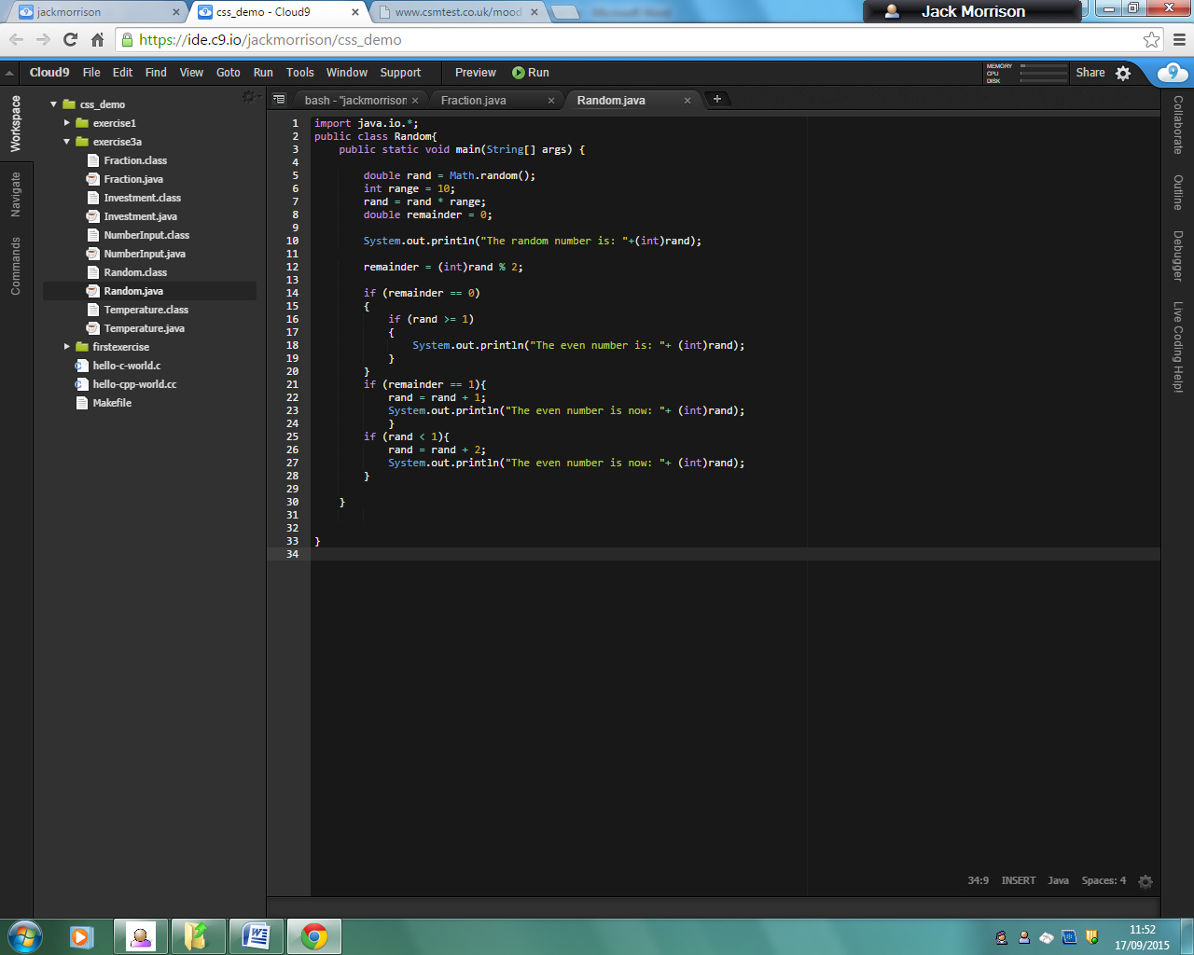

This is the code for the program Random.java.

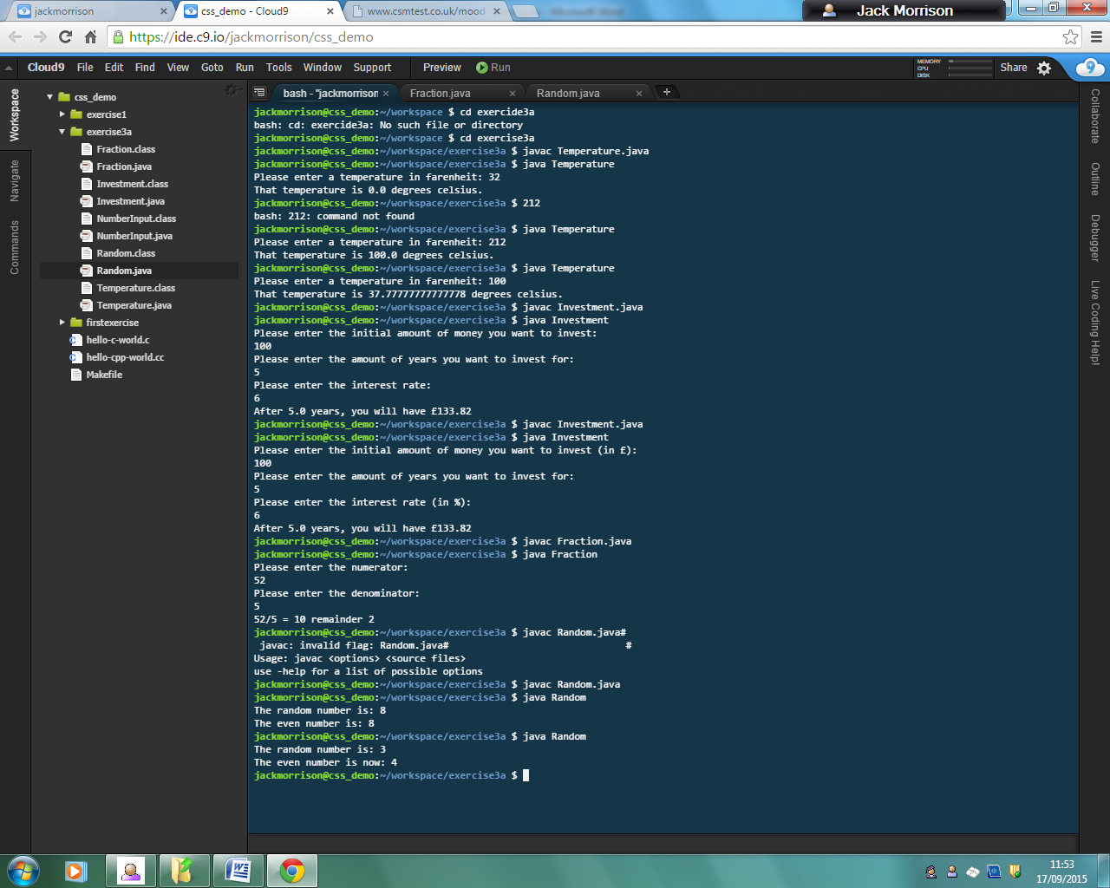

This shows the outcome of the program.

In the first case, the random integer between 1 and to is 8, and therefore because it is determined even by using the modulus, it stays the same.

In the second case, the random integer selected was 3. This is not determined as an even number by using the modulus, so 1 is added to it to give the even number of 4.

**Exercise 3a – Written Exercises**

**Implicit and Explicit Casting**

1. The language is designed this way because a float is 32 bits, but a double is 64 bits. This means that a float will always be smaller than a double, so if you want to convert it to a double, there will be enough space to store the whole number, whereas if you wanted to convert a double to a float, you could potentially lose half of the data, as it could be 64 bits long and it would have to be shortened to 32 bits to become a float.
   1. False
   2. False
   3. False
   4. True
   5. True
   6. True
2. 1. Float
   2. Float
   3. Float
   4. Float
   5. Integer
   6. Integer
   7. Integer
   8. Double
   9. Double
   10. String
   11. String
   12. Integer
   13. Integer
   14. Boolean
   15. Integer
   16. Float
3. 1. a
   2. b
   3. b
   4. b
   5. a
   6. a
4. 1. 3 (Float)
   2. 4 (Integer)
   3. 10 (Float)
   4. 2 (Integer)
   5. 4 (Float)